CS251: Software Engineering I

2014-2015

Project Title : Snake game

Software Requirements Specifications

Leader name: Omar Adel Mohamed

# Team

|  |  |  |  |
| --- | --- | --- | --- |
| **ID** | **Name** | **Email** | **Mobile** |
| 20120250 | Omar Adel Mohamed | Omar.hero1994@hotmail.com | 01144452875 |
| 20120246 | Omar Ayman |  |  |
| 20120 | Mahmoud shehata |  |  |

Document Purpose and Audience :

-The purpose of this document to delineate software

specifications for a system for a snake game.

Software Purpose:

-Provide a server client fashion, snack game where player can play a snack game with any other player.

Audience: mobile users ,visitors of trade mall.

Class Diagram:

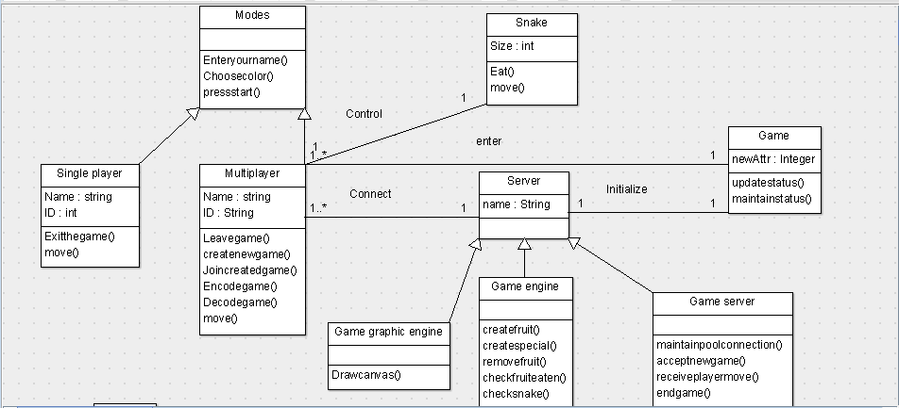

| **Class ID** | **Class Name** |  | **Description** |
| --- | --- | --- | --- |
| 1 | modes |  | This class is responsible of different modes |
| 2 | Single player |  | - It’s an entity class carries the attributes of the player (name,id). |
| 3 | multiplayer |  | - It's an entity class, carries the attributes of the user(name,id) and can leave game, start new game and join created game. |
| 4 | Server |  | - this class is the server where each player create on it the game. |
| 5 | Snake |  | - This class is snake carries the attribute of the snake (size) and can eat fruit and move. |
| 6 | Game engine |  | - This class is responsible of create fruit, create special, remove fruit and check fruit eaten. |
| 7 | Game server |  | This class is responsible maintain of connection, accept new game, receive snake move and ending of the game. |

Sequence diagram

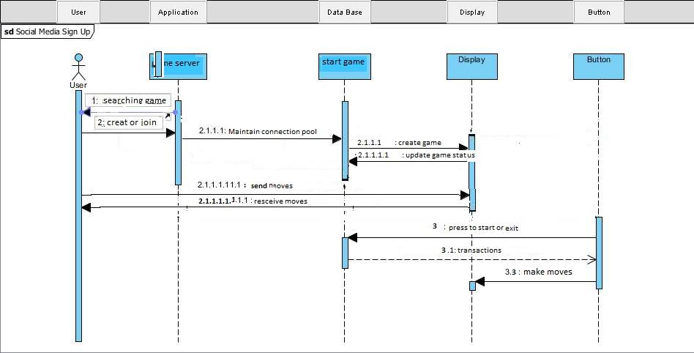

Interface:

